***flaws.cloud Level 1 Of S3 Bucket***

**Vulnerability Name :** Exposure Of S3 Bucket

**Steps To Reproduce :**

1. Open The flaws.cloud website.
2. Take The Level 1 Chalenge To Find The Flag 1.
3. With the help of **hint** and **video reference**
4. After that open the link of [**http://flaws.cloud.s3.amazonaws.com**](http://flaws.cloud.s3.amazonaws.com)
5. Then, Find The key that is Key-secret-dd02c7c.html
6. Next paste it on next to the portal of <http://flaws.cloud.s3.amazonaws.com> like :
7. <http://flaws.cloud.s3.amazonaws.com/secret-dd02c7c.html>
8. After That The Flag Arrives.

**Vulnerable Link :** <http://level2-c8b217a33fcf1f839f6f1f73a00a9ae7.flaws.cloud>

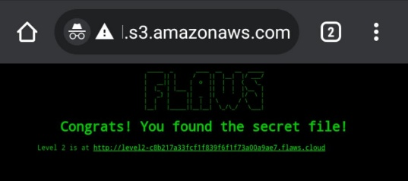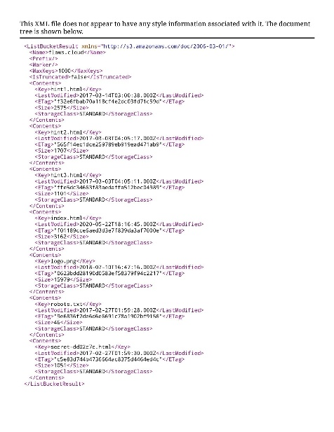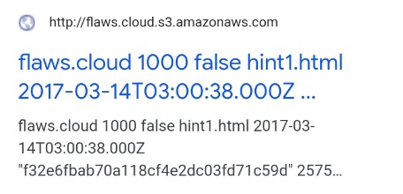**Proof Of Concept :** 